PRIVONT Real Estate Relationship & Lead Management Platform
Real Estate CRM | Agent Management | Lender Management | Vendor Management | Lead Management

Project Overview
PRIVONT is a secure web based real estate management platform built to centralize agents, lenders, vendors, leads, users, and business relationships in one system.
The platform combines a premium members experience with a structured administrative dashboard for managing business records.
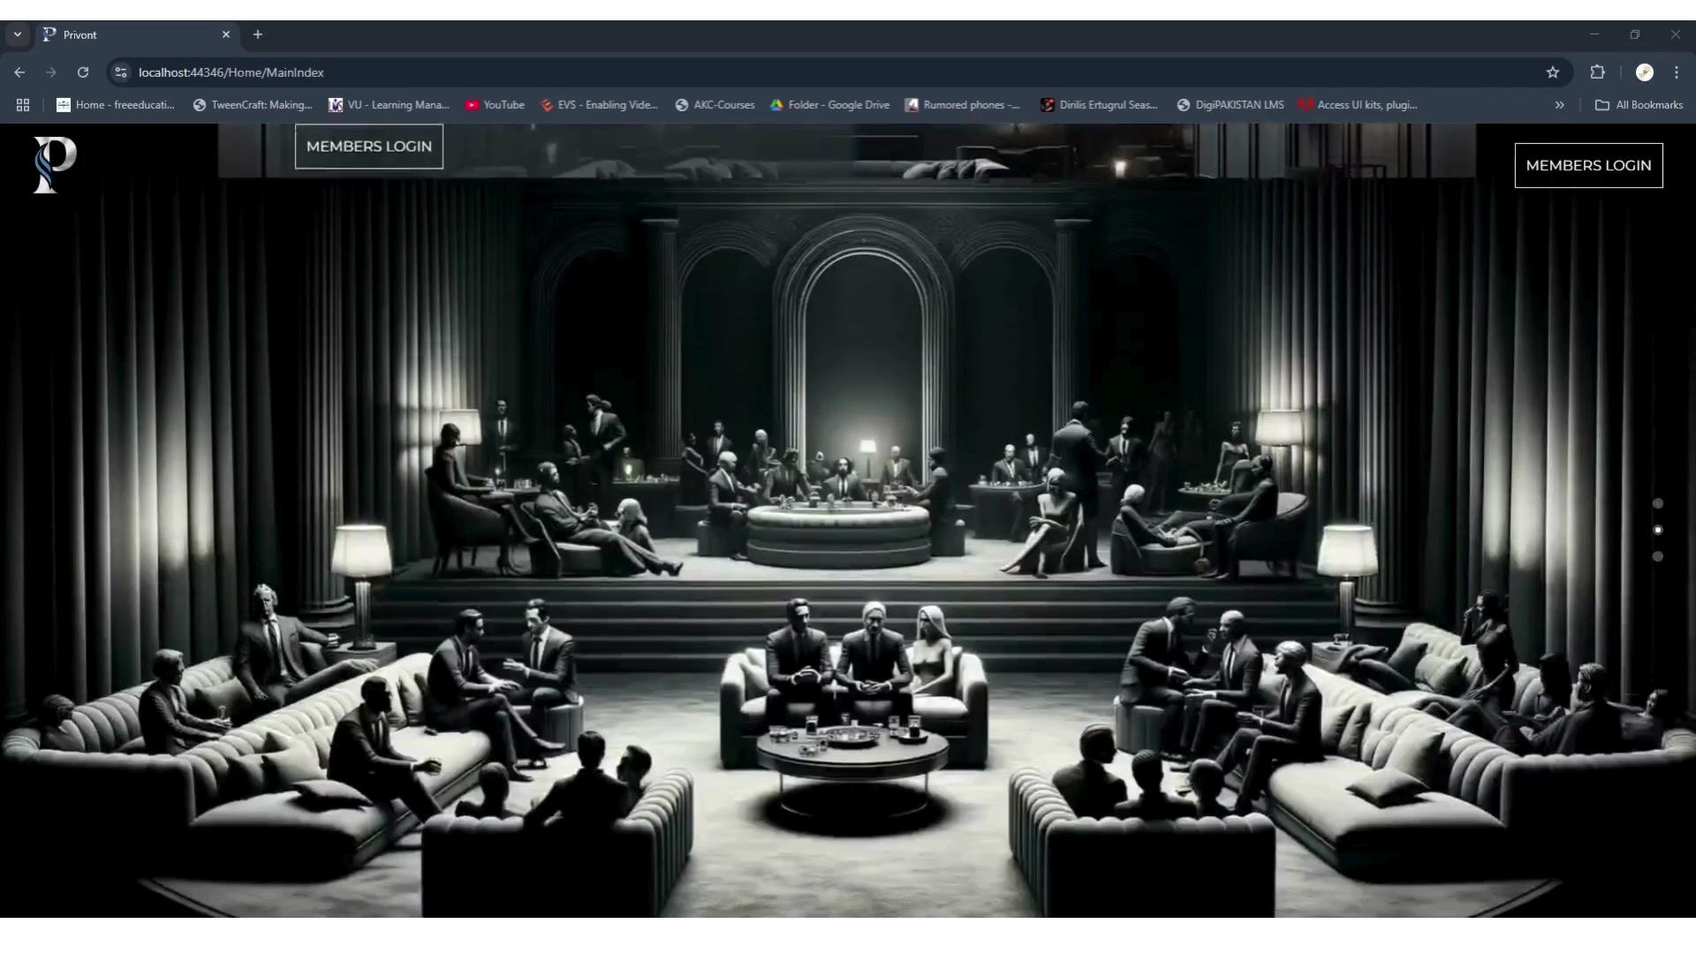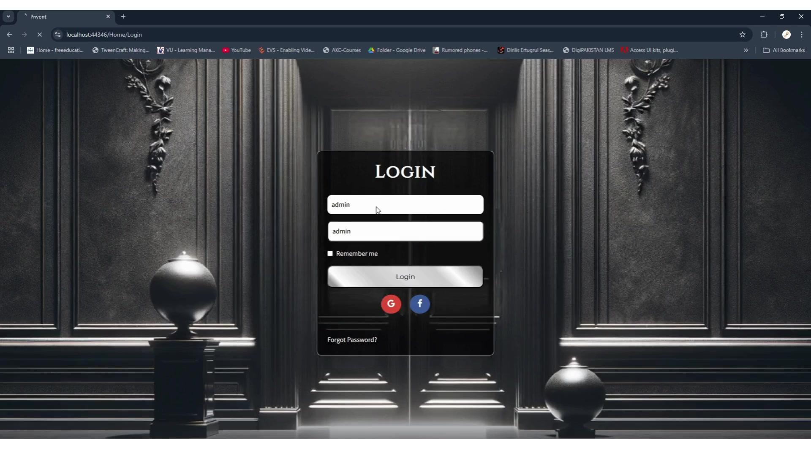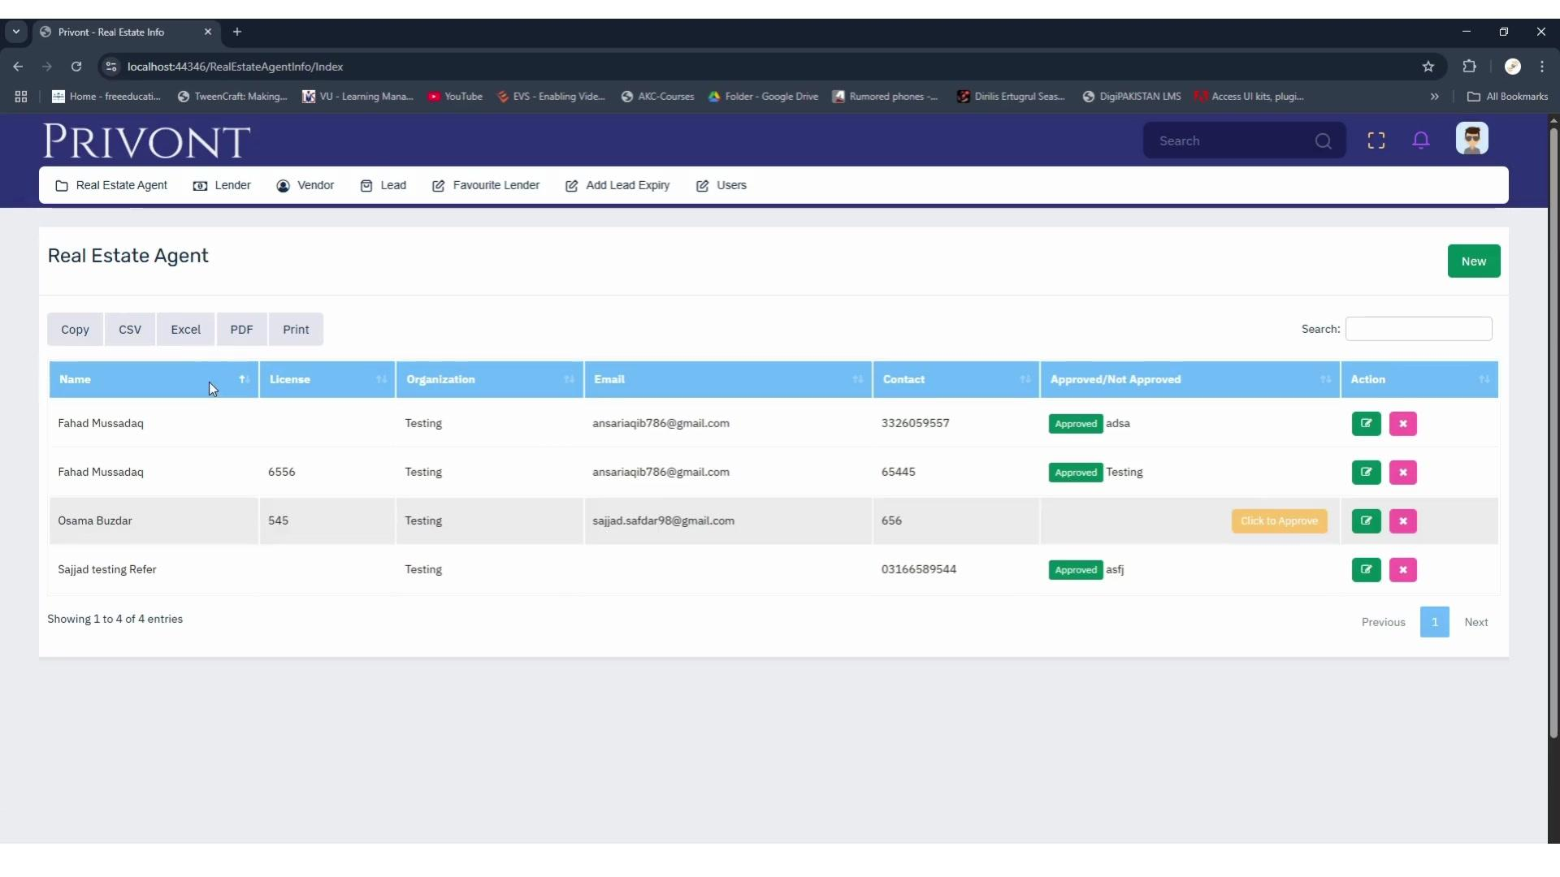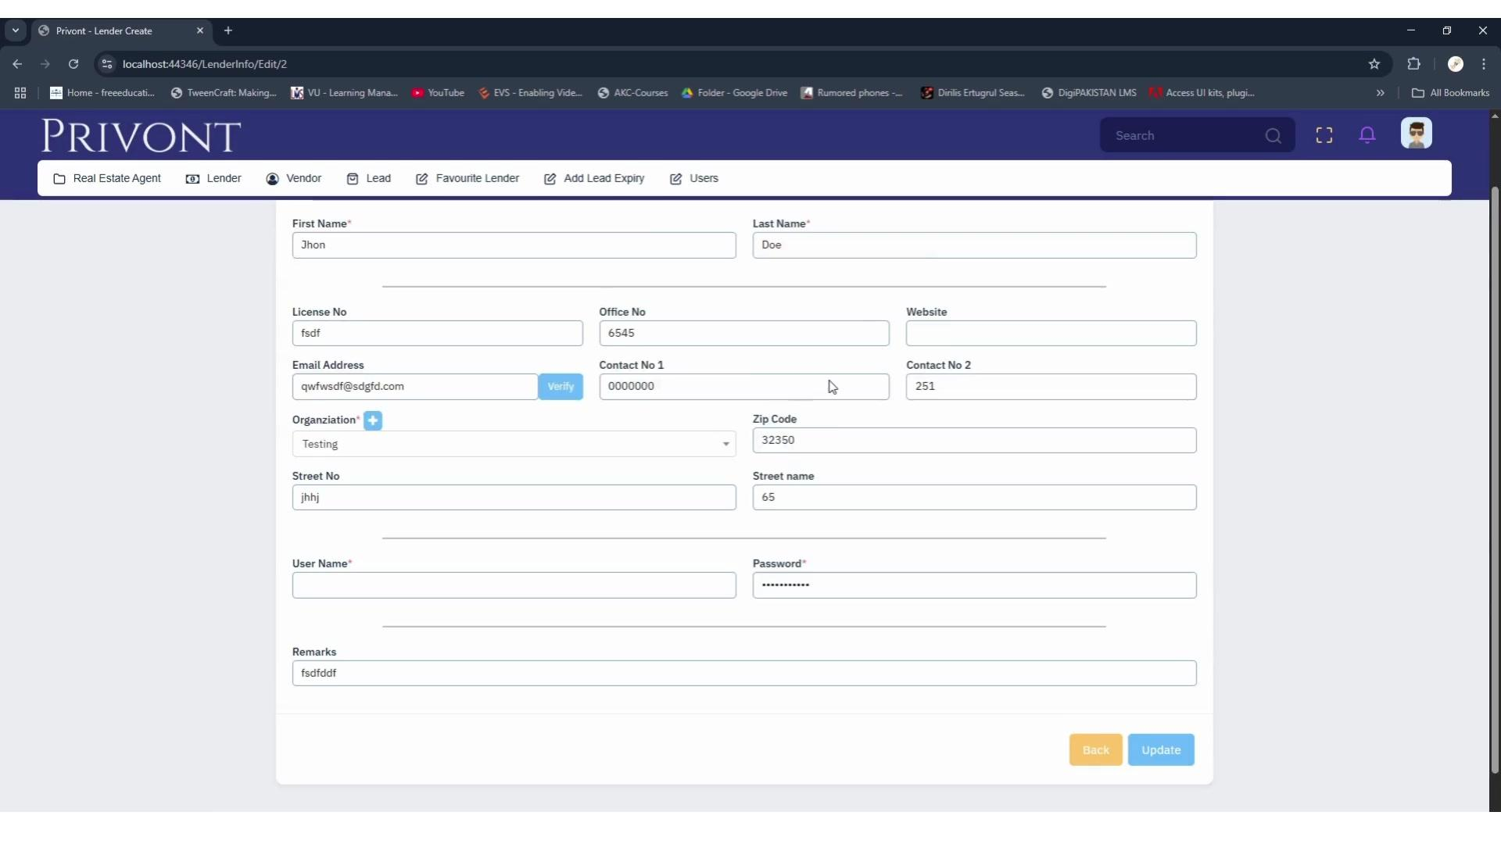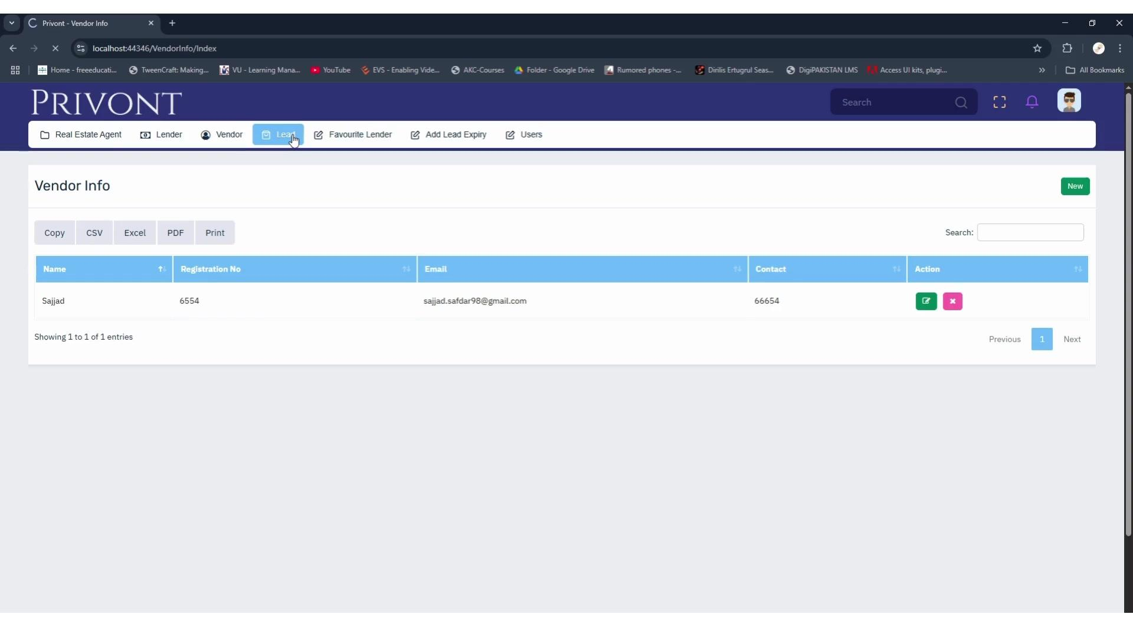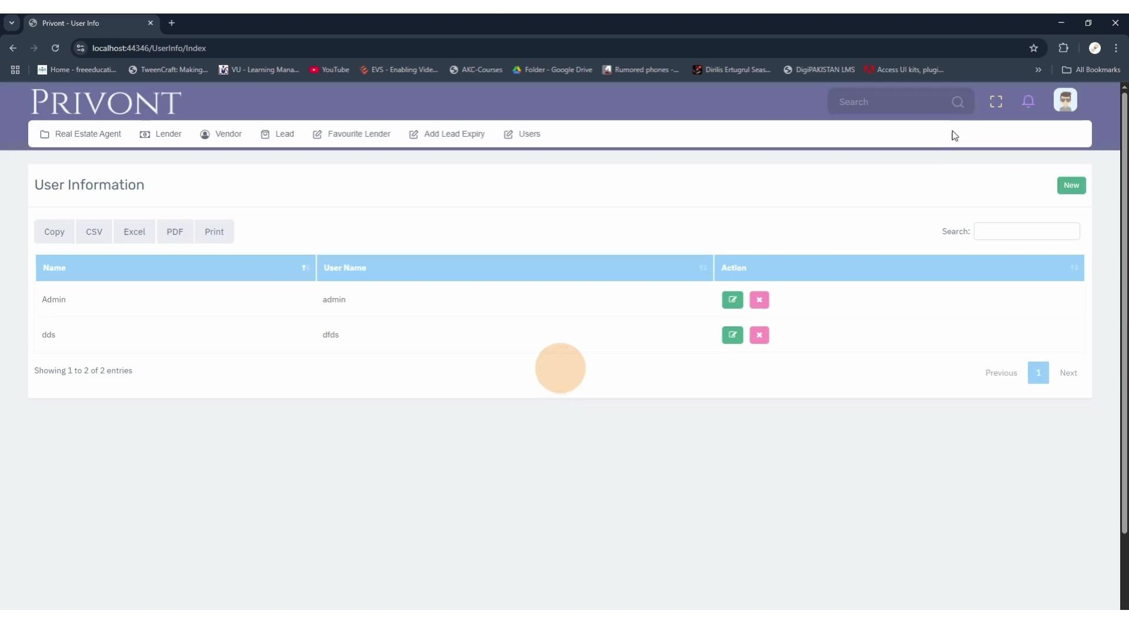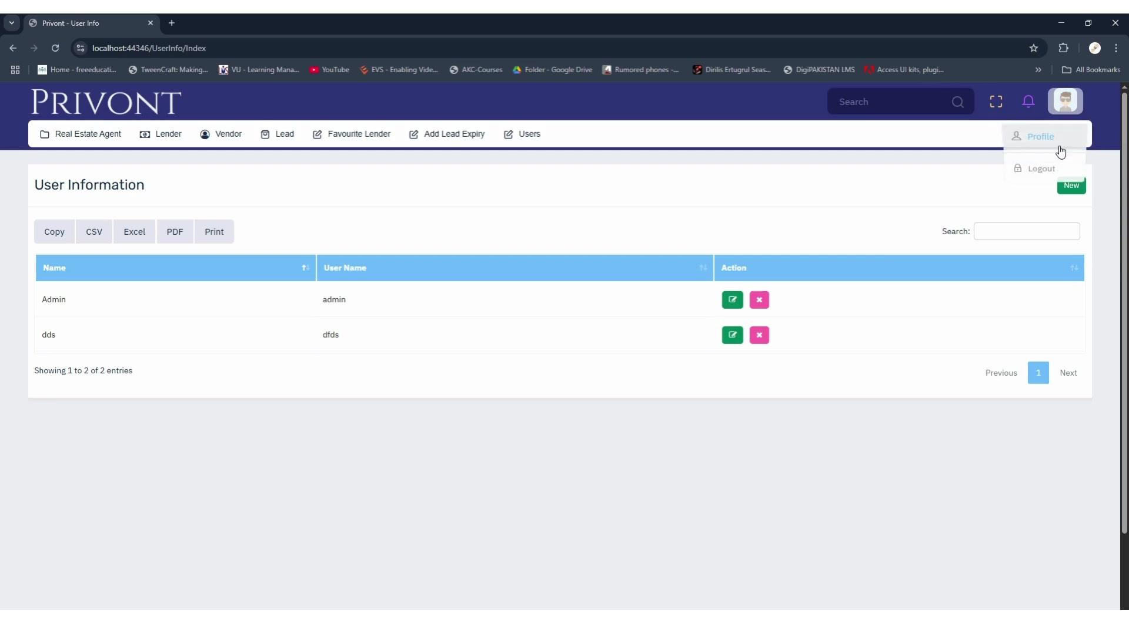

Main Modules
• Real Estate Agents
• Lenders
• Vendors
• Leads
• Favourite Lenders
• Lead Expiry
• Users
• Profile Management

Real Estate Agent Management
Administrators can manage agent records including:
• Name
• License
• Organization
• Email
• Contact
• Approval status
The module also supports search, sorting, pagination, create, edit, delete, export, and print functions.

Lender Management
The lender module provides detailed profiles with:
• Personal information
• License number
• Office number
• Website
• Email
• Multiple contact numbers
• Organization
• Address
• Username and password
• Remarks

Vendor Management
The vendor section maintains business vendor records with:
• Name
• Registration number
• Email
• Contact information
• Search
• Create, edit and delete
• CSV, Excel, PDF and print export

Lead Management
The platform includes dedicated areas for Leads, Favourite Lenders, and Lead Expiry, providing a structured foundation for managing real estate relationships and lead related activities.

User Management
Administrators can manage application users through a dedicated interface with:
• User listing
• Search
• New user creation
• Edit
• Delete
• Export
• Pagination

Authentication
The platform includes a members login experience with:
• Username and password
• Remember Me
• Forgot Password
• Google sign in option
• Facebook sign in option

Admin Interface
The authenticated dashboard provides:
• Persistent navigation
• Global search
• Notifications
• Profile access
• Data tables
• Search and filtering
• Export options
• Pagination
• Record management actions

Result
PRIVONT provides a centralized environment for managing real estate agents, lenders, vendors, leads, and users, while standardizing common business operations such as record management, approval, searching, exporting, and administration.
The result is a clean and organized real estate relationship management platform designed around secure access and efficient business record management.

